Promoting your Certification

TQCSI’s logo and certification marks are recognised worldwide.

No matter which program you are certified for, take advantage of the worldwide
acknowledgment of third party certified systems to promote your business.

Promote your certification and benefit from enhanced customer confidence.

Your Certification
You can promote your certification using the following examples of Certification Marks:
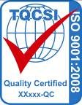
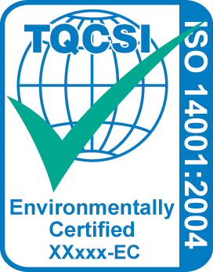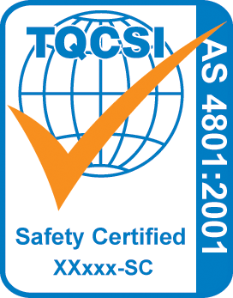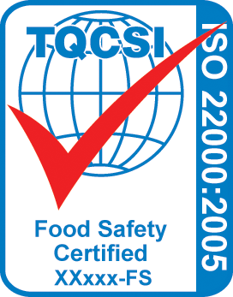

Email info@tqcsi.com to receive your Company’s personalised Certification Mark(s).

Promotional material is available through TQCSI, or you may create your own promotional material displaying your Certification Mark.

How to Display Your Certification Mark

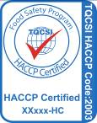
You may display your Certification Mark on any or all of your Company’s promotional material as long as you do not infer your products are certified; it is your management system which has been certified (see TQCSI Rules of Certification).

Always include a description of your certification and, wherever possible, include your Registration Number and the Standard, as shown in the examples.

E-Certificates and Website Links
Electronic certificates (E-Certificates) are displayed on the TQCSI website (www.tqcsi.com) listed under Certified Organisations. You may link your own website to TQCSI’s site and/or link directly to your E-Certificate.

TQCSI Pantone Colours
Blue (Pantone PMS 285) for all writing and the outline of the world; the tick should be red (Pantone PMS 485) for quality and food safety, green (Pantone Green) for environmental and QHSE, and orange (Pantone 021) for OHS. However, to save on printing costs, we allow the same colour to be used as your Company colour in mono colour documents; other different colours are not allowed.

Display your certification with pride

 | Unit  Price | Quantity |  |  |  |  |  | Total Price
 | Unit  Price | ISO 9001 | ISO 14001 | ISO 22000 | AS 4801 | HACCP | QHSE | Total Price
Vinyl Stickers - Size A5  UV proof  internal sticker | $11.00
Vinyl Stickers - Size A5  UV proof  external sticker | $11.00
Building Signs  Dilite  600 mm x 900 mm | $99.00
Certificate of Registration (Framed) | $99.00
Certificate of Registration (Unframed) | $55.00
 |  | Portrait  82 mm x 300 mm |  |  | Landscape  246 mm x 111 mm
IMS Vinyl Sticker  (9001, 14001, 4801) | $16.50

Examples of Stickers & Building

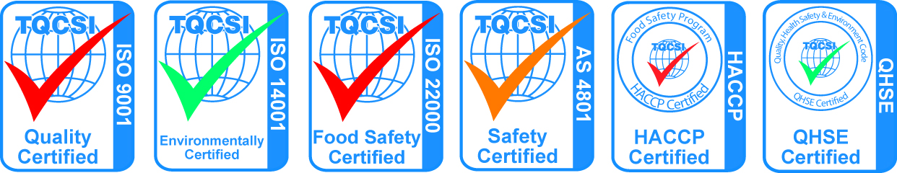
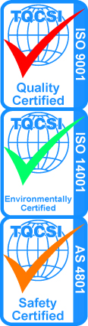

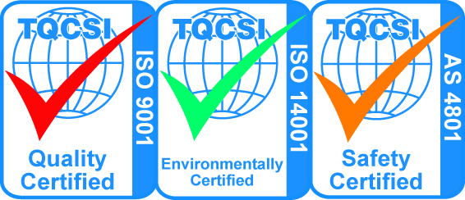

Company Name:
Purchase Order Number:
Signature: Date:

Note: Prices are inclusive of GST, postage may be charged

Please fax back to TQCSI on (08) 8445 9423

Please contact TQCSI if you are interested in promotional material for other systems.
TQCS International Pty Ltd
117A Tapleys Hill Road Hendon 5014 SA

ph: (08) 8347 0603  fax: (08) 8445 9423  email: info@tqcsi.com
www.tqcsi.com

